**‘Subscribe’ Page** – This page provides you with several available products for your pet and lets you subscribe to your preferred products. The subscribe button prompts you to enter your credit details.

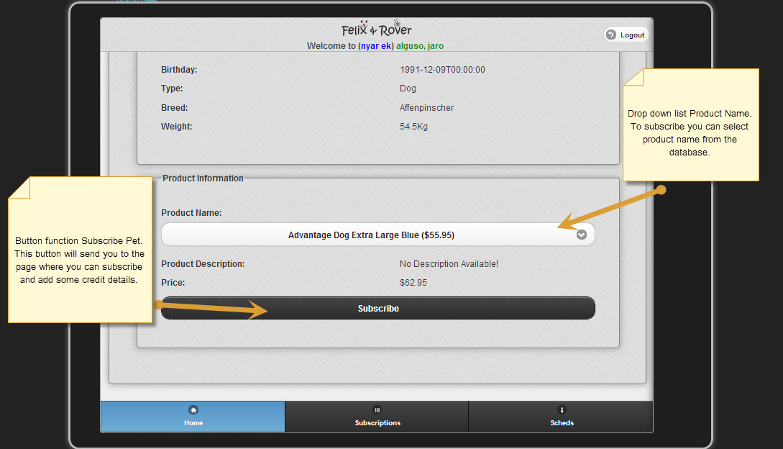

**‘Credit Details’ Page** – This is where you enter your credit card details for your mode of payment for your subscription

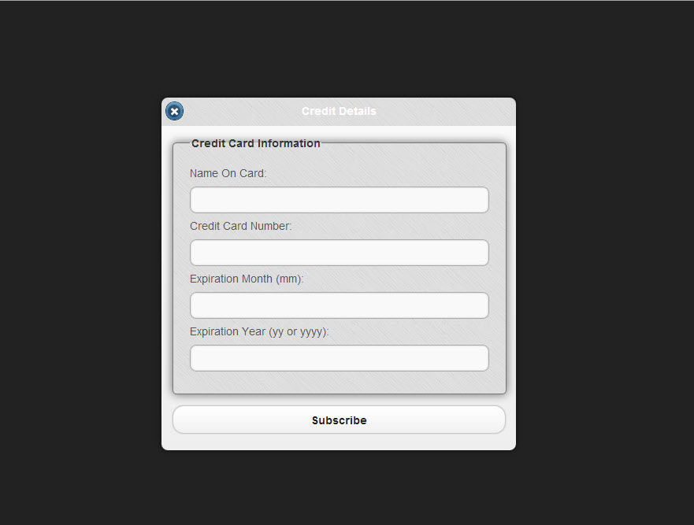

**‘Add Pets’ Page** – This page allows you to enter information for newly registered pets.

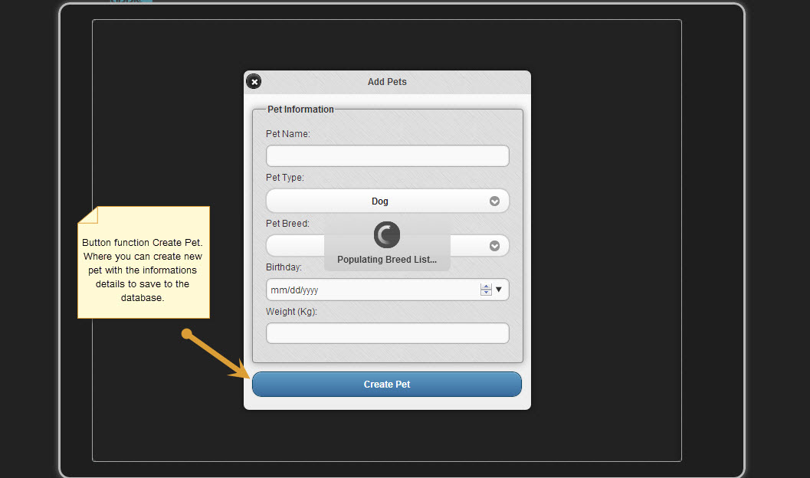

**Welcome Page** – This is the Felix and Rover welcome page, where you can login to an existing account or register a new account to be able to subscribe to available pet products.

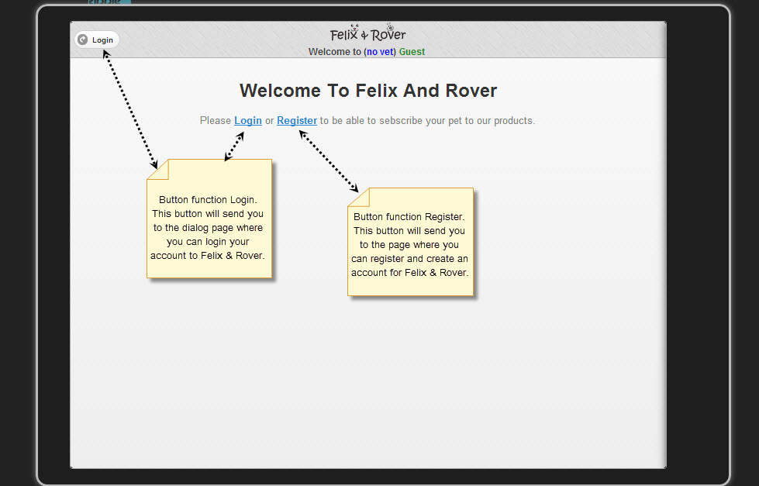

**Login Page** – This page prompts you to enter your login details for authentication. You may also register a new account using this page or reset your password.

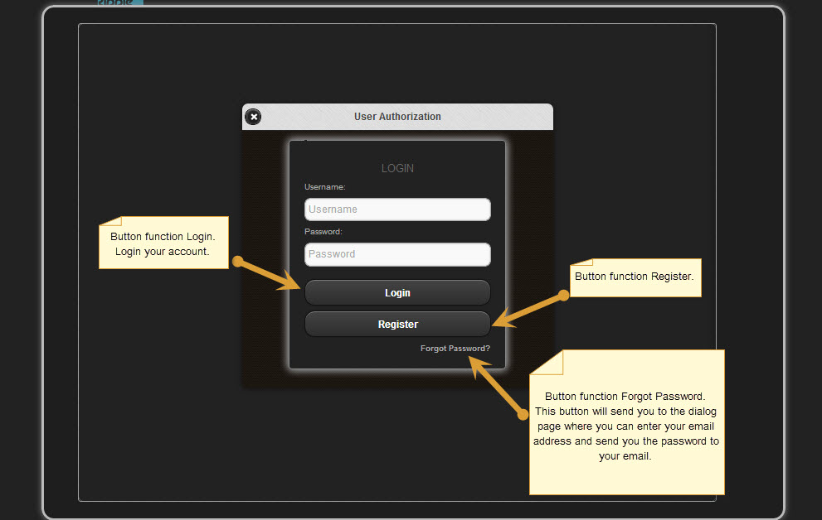

**‘Manage Subscriptions’ Page** – This page provides a list of your registered pets as well as subscriptions and allows you to add more pets.

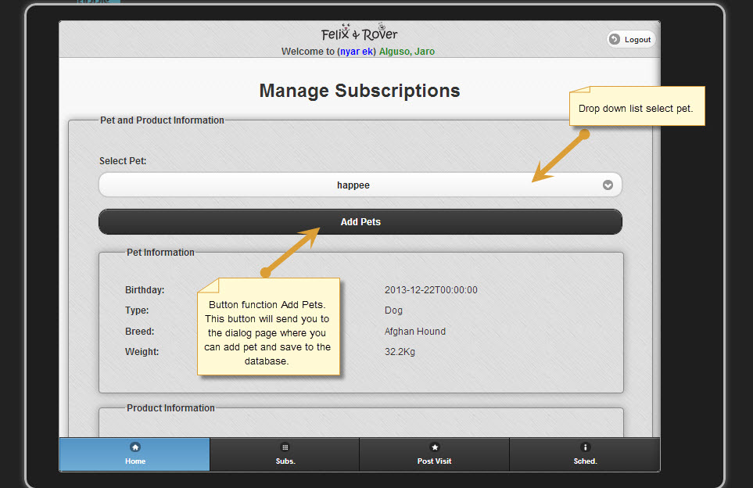

**User Registration Page** – This is where you provide necessary information to register a new account.

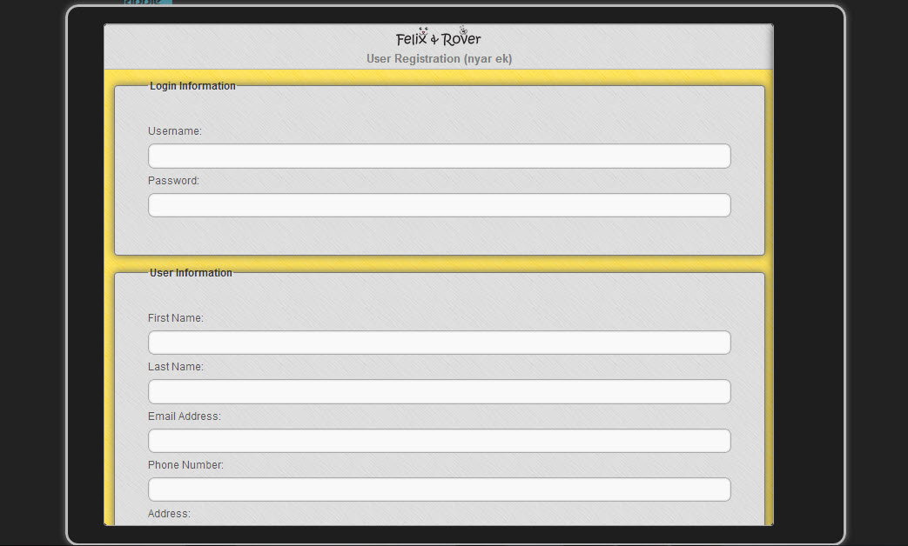

**Unsubscribe Page** – This is where you go to if you wish to cancel your subscription with a product.

